Think Green Campaign: Alternative Energy Sources

Group: Fatima Abdulla, Maitha Hammadi, Marzia Salman, Roudha Sumaiti, Khadija Ayali

Assigned to & done by: Fatima Abdulla

25 January 2014

10C G.

Mr. Omar Audi

**Table of Contents:**

Introduction 3

Solar Power 4

Hydropower 6

Wind Power 8

Geothermal Power 10

Strange Sources 12

Graphical Evidence 13

Steps You Can Take at Home 14

Conclusion 15

Bibliography 15

1. **Introduction:**

In this day and age, energy is the world’s number one need. With all the high tech gadgets to be charged, and skyscrapers to be powered, there is no shortage to the usage of power. However, there is a limit to the amount that can be supplied, before disastrous consequences. The main focus of this project is to identify different sources we can use instead, as it would benefit the world entirely.

Some may think that there *is* no other source of energy; but there is. Some may be completely obvious, and some bizarre, but useful. There is the most obvious, solar power. There *are* other more. Did you know that vibrations give off power as well? Sugar and body heat can produce power as well.

Here are some figures you probably didn’t know:

1. An average American household uses up more than 10,837 kWh yearly.
2. A midsize refrigerator uses about 322 kWh a year
3. An iPhone uses about 361 kWh a year
4. A single megawatt can power about 250 homes.

Yet today, technology produces only one tenth of one percent of global energy demand.

There are two kinds of energy:

1. Renewable energy: generated from natural resources,  
    *sunlight wind, rain, tides and geothermal heat  
   which are naturally replenished.
2. Alternative energy can be widely produced with basic equipment and naturally basic processes. Wood, the most renewable and available alternative energy, burns the same amount of carbon it would emit if it degraded naturally.
3. **Solar Power:**

You've seen the panels on rooftops and mirrors in the desert. But how much do you really know about the technology needed to capture the tremendous power of the sun? (***Figure1.2)***

Did you know that the amount of sun that reaches the earth estimates to 120K terawatts. That is about 6 thousand times the world’s estimated 20 terawatt electricity demand by 2020.

Germany takes the lead for the country that has installed the most solar panels, which produces 400 MW of solar power capacity per million people. Italy at 267 MW per million people, #3 Belgium at 254 MW per million people, and #4 Czech Republic at 204 MW per million, and #5 Greece at 143 MW per million people. The US came it at #20 with about 25 MW per million people.

The use of solar PV panels are by far the only way electricity can be generated, without moving parts. They can be used very efficiently, and require very little water, whuch is used to keep the surfaces sanitary,

Just like the solar panels, wind energy is very effective to use, and only need water for cleaning.

Photovoltaic cells, or PV panels, are made up of a kind of semiconductor material that are similar in physical appearances to a computer chip. When sunlight hits these panels, it dislodges electrons from the atoms. The electrons that flow through the cell generates electricity.

If talked about on the basis of supplying energy to a large number of communities, there are certain techniques used to concentrate the sun’s heat force for utility. One technique includes manageable mirrors to focus the sun's rays on a tower, where a receiver sits, and collects the energy. Molten salt flowing through the receiver is heated to run a generator. ***(Figure1.1)***

Solar energy is highly approved due to it being a versatile, inexhaustible source that lacks the deal breakers of pollution and noise. Unfortunately, there is a downside. Without a battery to store extra energy, a solar power cell would fail at night, or on a particularly cloudy and dark day. Not only that, but the path to accommodating such technology would require deep pockets and a large area to collect energy at useful rates. Solar power takes time to collect.

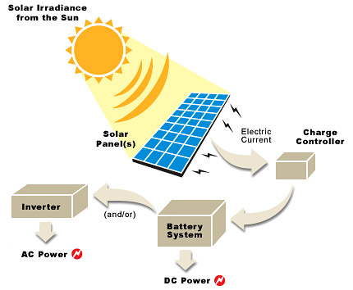

***(Figure1.1)***

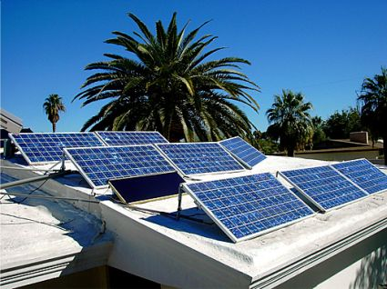

***(Figure1.2)***

1. **Hydropower:**

Hydro-power is also known as water power. Just like its name clearly portrays, it is the power derived from falling water’s energy. Even in ancient times, the power of water has been harnessed for the use of farm and livestock reasons. Examples include being used for [irrigation](http://en.wikipedia.org/wiki/Irrigation) and the operation of a variety of mechanical devices, that include [watermills](http://en.wikipedia.org/wiki/Watermill) and [sawmills](http://en.wikipedia.org/wiki/Sawmill). ***(Figure2.1)***

Since the early 20th century, the term has been used almost exclusively in conjunction

Hydropower is used primarily to generate [electricity](http://en.wikipedia.org/wiki/Electricity). Categories include:

* [Run-of-the-river hydroelectricity](http://en.wikipedia.org/wiki/Run-of-the-river_hydroelectricity), which captures the kinetic energy in rivers or streams, without the use of dams.
* [Small hydro](http://en.wikipedia.org/wiki/Small_hydro) projects are 10 megawatts or less and often have no artificial reservoirs.
* [Micro hydro](http://en.wikipedia.org/wiki/Micro_hydro) projects provide a few kilowatts to a few hundred kilowatts to isolated homes, villages, or small industries.
* [Conduit hydroelectricity](http://en.wikipedia.org/wiki/Conduit_hydroelectricity) projects utilize water which has already been diverted for use elsewhere; in a municipal water system for example.
* [Pumped-storage hydroelectricity](http://en.wikipedia.org/wiki/Pumped-storage_hydroelectricity) stores water pumped during periods of low demand to be released for generation when demand is high.

The most commonly known example of collecting energy from water is this; placing in a river, a water wheel picks up flowing water in buckets located around the wheel. The kinetic energy of the flowing river turns the wheel and is converted into mechanical energy that runs the mill.

A typical hydro plant is a system with three parts: an electric plant where the electricity is produced; a dam that can be opened or closed to control water flow; and a reservoir where water can be stored. The water behind the dam flows through an intake and pushes against blades in a turbine, causing them to turn. The turbine spins a generator to produce electricity. The amount of electricity that can be generated depends on how far the water drops and how much water moves through the system. The electricity can be transported over long-distance electric lines to homes, factories, and businesses.

The first hydroelectric power plant was built at Niagara Falls in 1879. In 1881, street lamps in the city of Niagara Falls were powered by hydropower. In 1882 the world’s first hydroelectric power plant began operating in the United States in Appleton, Wisconsin.

Did you know that China, Canada, Brazil, the United States, and Russia were the five largest producers of hydropower in 2004?

Hydropower is the cheapest way to generate electricity today. That's because once a dam has been built and the equipment installed, the energy source—flowing water—is free. It's a clean fuel source that is renewable yearly by snow and rainfall.

Hydropower is also readily available; engineers can control the flow of water through the turbines to produce electricity on demand. In addition, reservoirs may offer recreational opportunities, such as swimming and boating.

Despite the great advantages, there are consequences. Damming rivers may destroy or disrupt wildlife and other natural resources (***Figure2.2)***. Some fish, like salmon, may be prevented from swimming upstream to spawn. Technologies like fish ladders help salmon go up over dams and enter upstream spawning areas, but the presence of hydroelectric dams changes their migration patterns and hurts fish populations. Hydropower plants can also cause low dissolved oxygen levels in the water, which is harmful to river habitats.

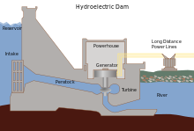

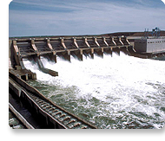

***(Figure2.2)***

***(Figure2.1)***

1. **Wind Power:**

Wind is the movement of air from an area of high pressure to an area of low pressure. Wind exists because the sun unevenly heats the surface of the Earth. As hot air rises, cooler air moves in to fill the void. As long as the sun shines, the wind will blow. And as long as the wind blows, people will harness it to power their lives.

Boaters in the past used sails to capture the wind and explore the world. Farmers once used windmills as well, to grind their grains and pump their water. Today, an increasing number of people are using wind turbines to wring electricity from the breeze. Over the past decade, the use of wind power has increased more than 25 percent a year. Still, it only provides a small fraction of the world's energy.

Turbines can be as tall as a 20-story building and have three 200-foot-long blades. These contraptions look like giant airplane propellers on a stick. The wind spins the blades, which turn a shaft connected to a generator that produces electricity. Other turbines work the same way, but the turbine is on a vertical axis and the blades look like a giant egg beater. ***(Figure3.1/2)***

The biggest wind turbines generate enough electricity to supply about 600 homes. Wind farms have tens and sometimes hundreds of these turbines lined up together in particularly windy spots. Smaller turbines erected in a backyard can produce enough electricity for a single home or small business.

Wind is a clean source of renewable energy that produces no air or water pollution. And since the wind is free, operational costs are nearly zero once a turbine is put up. Mass production and technology advances are making turbines cheaper.

Some people do think wind turbines make too much noise. The rotating blades can sometimes kill birds and bats as well. The wind can be variable; if it’s windy, great, but if it isn’t, not power will be generated.

Nevertheless, the wind energy industry is booming. Globally, generation more than quadrupled between 2000 and 2006. At the end of last year, global capacity was more than 70,000 megawatts. Along with solar panels, Germany has the most installed wind energy capacity, followed by Spain.

Industry experts predict that if this pace of growth continues, by 2050 the answer to one third of the world's electricity needs will be found blowing in the wind.

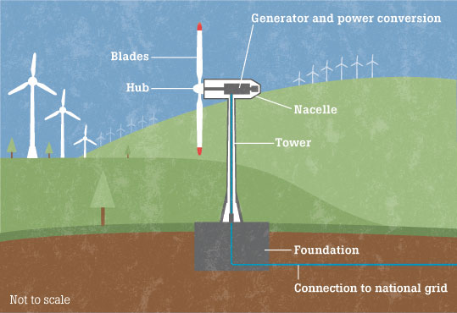

***(Figure3.1)***

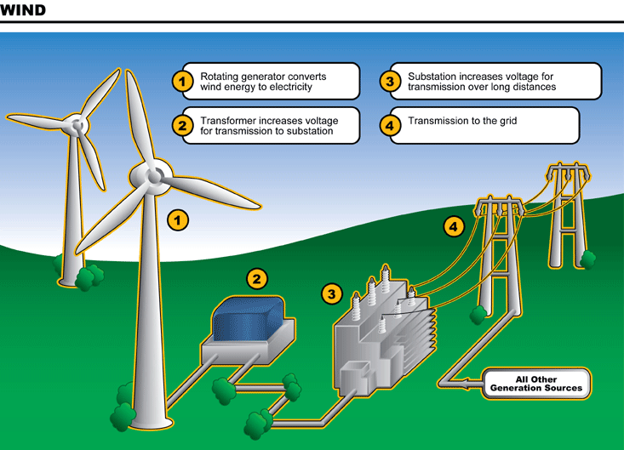

***(Figure3.2)***

1. **Geothermal Power:**

Geothermal power is the utilization of natural sources of heat found inside the Earth, to produce heat or electricity. The world’s biggest source of geothermal power is currently from generating through steam or hot water that is found underground. A positive note; geothermal power generation produces few emissions and the power source is continuously available.

There are three geothermal technologies currently used:   
Direct-use systems  
Use of deep reservoirs to generate electricity  
Geothermal heat pumps.

1. Direct-use geothermal systems:  
    A well is drilled into a reservoir to provide a steady flow of hot water. The water is brought up through the well, through the mechanical system of piping, a heat exchanger, and controls, then delivers the heat directly for the intended use. To dispose of it, a system either injects the cooled water underground, or disposes of it in a surface storage pond. Geothermal hot water can be used for heating buildings, raising plants in greenhouses, drying crops, or for industrial processes. Most reservoirs in the US are in the west, as it tends to have a greater source of heat underground. *(****Figure4.1)***
2. Geothermal power plants:  
    Converts hydrothermal fluids, such as hot water or steam to electricity. The oldest type of geothermal power plant uses steam, which is accessed through deep wells, to directly drive a turbine to produce electricity. There are two types of plants:  
   a. Flash steam plants use extremely hot water (149 degrees + C), which is pumped under high pressure to the generation equipment at the surface. The hot water is vaporized and the vapor in turn drives turbines to generate electricity.   
     
   b. Binary-cycle geothermal power plants use moderate-temperature water (38-149 degrees C). The water is used to vaporize a second fluid that has a much lower boiling point than water. The vapor from this second fluid is then used to drive the turbines to produce electricity.
3. Geothermal Heat Pumps:  
    These are used for space heating and cooling as well as water heating, for residential and commercial applications. The technology relies on the fact that beneath the surface, the Earth remains at a relatively constant temperature throughout the year, warmer than the air above it during the winter and cooler in the summer. A geothermal heat pump takes advantage of this by transferring heat, stored in the ground, into a building during the winter, and transferring it out of the building and back into the ground during the summer. The heat pump consists of a series of pipes, buried in the ground near a building to be conditioned or where water is to be heated. Fluid is circulated through the pipes to either absorb heat from the ground or distribute heat to the ground. Geothermal heat pumps can be used in most areas of the United States.

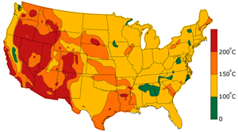

***(Figure4.1)***

While geothermal energy use is efficient, reliable, and environmentally friendly, it currently meets less than 1% of U.S. power needs.

1. **Other Strange Sources:**

|  |  |
| --- | --- |
| Source | Explanation |
| Biomass | Energy taken for plants and grasses ***(Figure5.1)*** |
| Sludge | Thick soft mud that can produce up to 10 million kilowatt-hours of electricity per day |
| Jellyfish | contain the raw ingredients for a new kind of fuel cell, which is green fluorescent protein, GFP. (Figure5.2) |

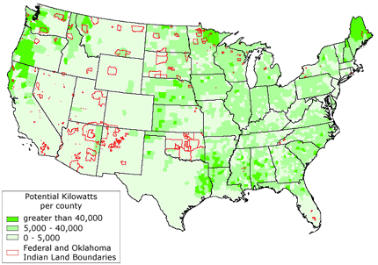

***(Figure5.1)***

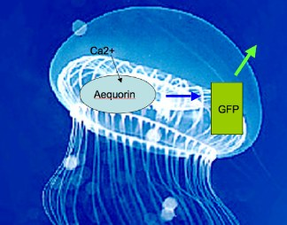

***(Figure5.2)***

1. **Graphical Evidence:**

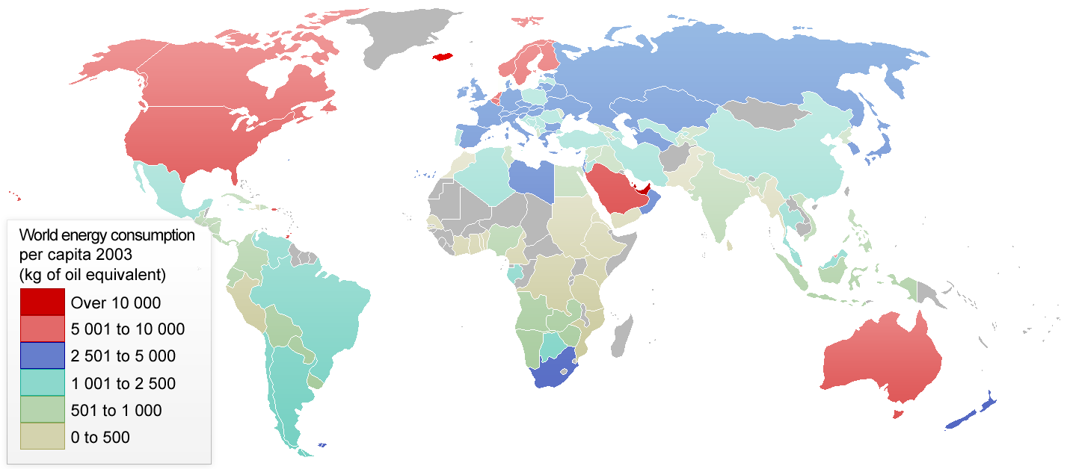

How Much Could We Save If We Harness Solar and Wind with Electric Vehicles?

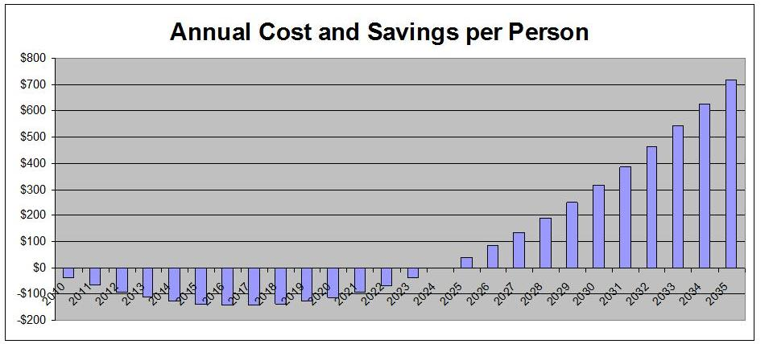

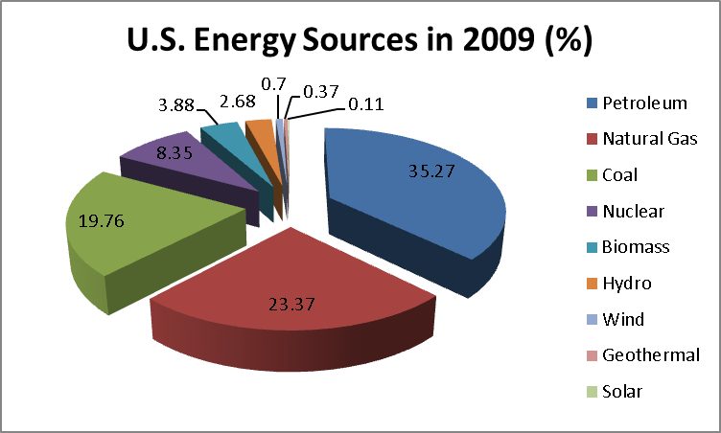

1. Steps You Can Take at Home To Save Energy:
2. Turn down the thermostat. Turning the thermostat down by even a single degree can do wonders for the environment. You won’t even be able to tell the difference.
3. Wash wisely. Only use the washing machine when you have collected a full load. Dryers use up a large quantity of energy. Hang your clothes on a line instead.
4. Take a shower instead of a bath. It uses around 50 percent less energy.
5. Turn off machines and lighting. Turn off any appliances you are not using. Turn off the lights when you leave the room.
6. Turn off your computer. Screen savers can use more energy than when you are using the computer yourself and can reduce the life of your monitor.
7. **Conclusion**:

It really is quite simple to reduce your carbon footprint. No, you don’t have to install thousands of dollars worth of solar panels. All you need to do is turn out the light. The smallest steps can make the biggest of differences. Change starts with one. Tuesday April 22; Earth Day. Save the date, and turn off that light!

1. **Bibliography**:

<http://nationalatlas.gov/articles/people/a_energy.html>  
<http://www.foxnews.com/science/2013/11/21/11-bizarre-sources-for-alternative-energy/>  
<http://en.wikipedia.org/wiki/Hydropower>  
<http://environment.nationalgeographic.com/environment/global-warming/hydropower-profile/>  
<http://environment.nationalgeographic.com/environment/global-warming/wind-power-profile/>  
<http://www.eia.gov/tools/faqs/faq.cfm?id=97&t=3>

<http://www.renewableenergyworld.com/rea/blog/post/2010/03/how-much-could-we-save-if-we-harness-solar-and-wind-with-electric-vehicles-to-end-oil-dependence-and-eliminate-carbon-dioxide-as-a-problem>  
<http://theweek.com/article/index/248273/your-iphone-uses-more-energy-than-a-refrigerator>

